Packet Tracer – Skills Integration Challenge

1. Topology

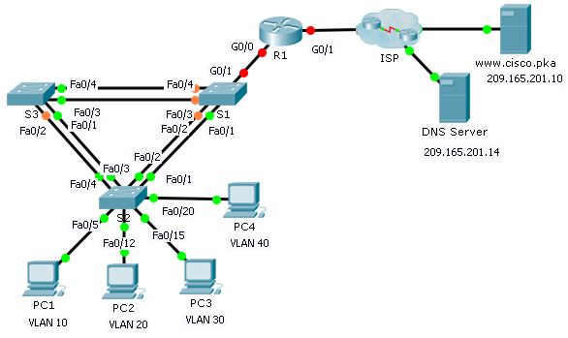

1. Addressing Table

|  |  |  |  |  |
| --- | --- | --- | --- | --- |
| Device | Interface | IP Address | Subnet Mask | Default Gateway |
| R1 | G0/0.10 | 172.31.10.1 | 255.255.255.224 | N/A |
| G0/0.20 | 172.31.20.1 | 255.255.255.240 | N/A |
| G0/0.30 | 172.31.30.1 | 255.255.255.128 | N/A |
| G0/0.40 | 172.31.40.1 | 255.255.255.192 | N/A |
| G0/1 | DHCP Assigned | DHCP Assigned | N/A |
| PC1 | NIC | DHCP Assigned | DHCP Assigned | DHCP Assigned |
| PC2 | NIC | DHCP Assigned | DHCP Assigned | DHCP Assigned |
| PC3 | NIC | DHCP Assigned | DHCP Assigned | DHCP Assigned |
| PC4 | NIC | DHCP Assigned | DHCP Assigned | DHCP Assigned |

1. VLAN Port Assignments and DHCP Information

|  |  |  |  |
| --- | --- | --- | --- |
| Ports | VLAN Number - Name | DHCP Pool Name | Network |
| Fa0/5 – 0/9 | VLAN 10 - Sales | VLAN_10 | 172.31.10.0/27 |
| Fa0/10 – Fa0/14 | VLAN 20 - Production | VLAN_20 | 172.31.20.0/28 |
| Fa0/15 – Fa0/19 | VLAN 30 - Marketing | VLAN_30 | 172.31.30.0/25 |
| Fa0/20 - Fa0/24 | VLAN 40 - HR | VLAN_40 | 172.31.40.0/26 |

1. Scenario

In this culminating activity, you will configure VLANs, trunks, DHCP Easy IP, DHCP relay agents, and configure a router as a DHCP client.

1. Requirements

Using the information in the tables above, implement the following requirements:

* Create VLANs on **S2** and assign VLANs to appropriate ports. Names are case-sensitive
* Configure **S2** ports for trunking.
* Configure all non-trunk ports on **S2** as access ports.
* Configure **R1** to route between VLANs. Subinterface names should match the VLAN number.
* Configure **R1** to act as a DHCP server for the VLANs attached to S2.
  1. Create a DHCP pool for each VLAN. Names are case-sensitive.
  2. Assign the appropriate addresses to each pool.
  3. Configure DHCP to provide the default gateway address
  4. Configure the DNS server 209.165.201.14 for each pool.
  5. Prevent the first 10 addresses from each pool from being distributed to end devices.
* Verify that each PC has an address assigned from the correct DHCP pool.

**Note:** DHCP address assignments may take some time. Click **Fast Forward Time** to speed up the process.

* Configure **R1** as a DHCP client so that it receives an IP address from the ISP network.
* Verify all devices can now ping each other and **www.cisco.pka**.